

**UNIVERSITI TEKNOLOGI MARA**

**PERAK BRANCH, TAPAH CAMPUS**

35400 Tapah Road

**College of Computing, Informatics and Media**

**Fundamentals of Algorithms & Computer Problem Solving**

**(CSC126)**

**Individual Assignment**

(Assessment 2)

|  |  |  |  |  |  |  |  |  |  |  |  |  |  |  |  |
| --- | --- | --- | --- | --- | --- | --- | --- | --- | --- | --- | --- | --- | --- | --- | --- |
| |  |  |  | | --- | --- | --- | | Prepared By : | **Student Name: SHEIKH ADAM BAJUNID BIN MOHD FAISAL** | **Student ID :**  **2023135385** | |  | **Group: 1A** | | |  |  | | | Prepared For: | **Lecturer’s name: MOHD FAAIZIE BIN DARMAWAN** | | |  |  | | |

**Deadline: 14 June 2023, 5:00 PM**

Question 1: Flowchart

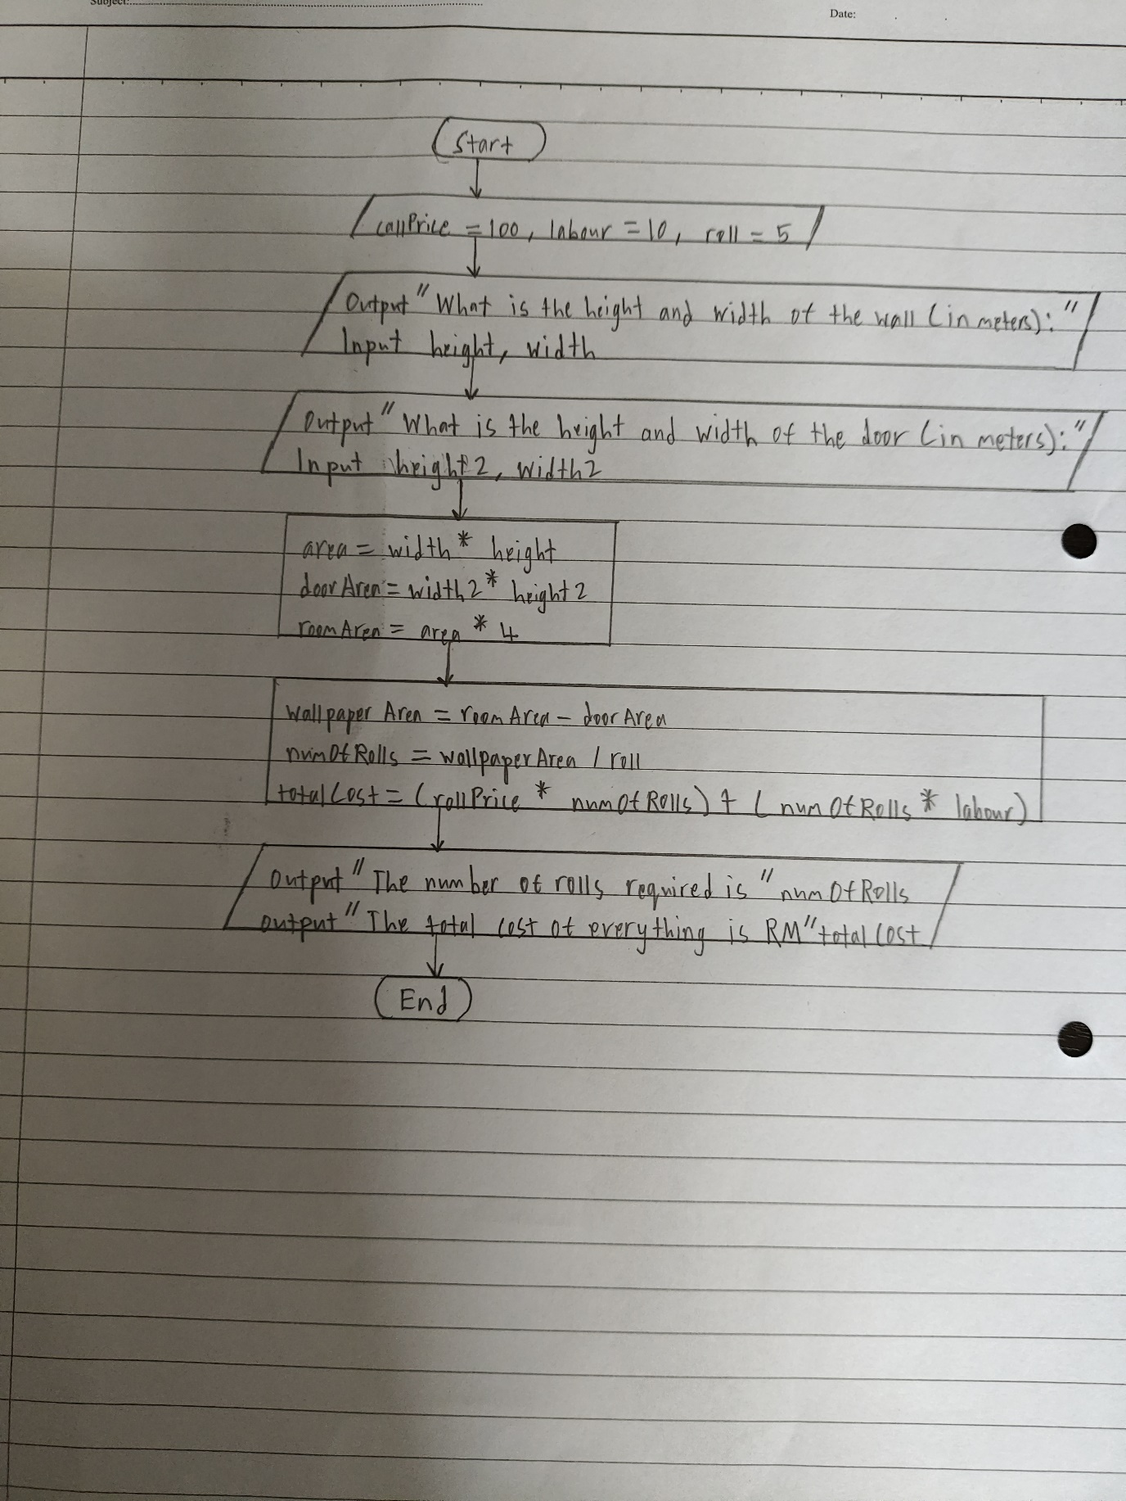

Question 1: Source Code

/*

Name : SHEIKH ADAM BAJUNID BIN MOHD FAISAL

Sid : 2023135385

Course : CSC126

Group : 1A

Due Date : 14 June 2023 5:00 pm

Question No : 1

Program Description : This program is used to calculate the price and number of wallpaper rolls required for Mr Rayyan

*/

#include <iostream>

using namespace std;

int main()

{

double numOfRolls, area, height, width, height2, width2, doorArea, rollPrice = 100, labour = 10, roll = 5, wallpaperArea, roomArea, totalCost;

cout<<"What is the height and width of the wall(in meters): ";

cin>>height>>width;

cout<<"What is the height and width of the door(in meters): ";

cin>>height2>>width2;

area = width * height;

doorArea = width2 * height2;

roomArea = area * 4;

wallpaperArea = roomArea - doorArea;

numOfRolls = wallpaperArea / roll;

totalCost = (rollPrice * numOfRolls ) + (numOfRolls * labour);

cout<<"The number of rolls required is "<<numOfRolls<<endl;

cout<<"The total cost of everything is RM"<<totalCost;

return 0;

}

Question 1: Output Screenshot

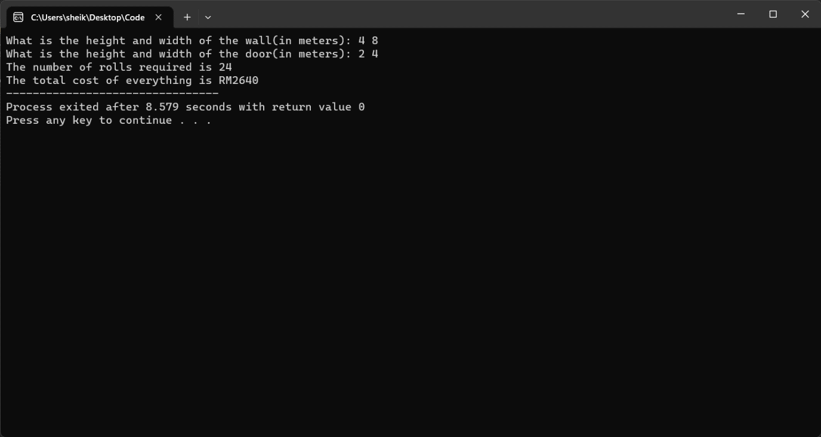

Question 2: Source Code

/*

Name : SHEIKH ADAM BAJUNID BIN MOHD FAISAL

Sid : 2023135385

Course : CSC126

Group : 1A

Due Date : 14 June 2023 5:00 pm

Question No : 2

Program Description : This program can calculate the final price for Bloom & Care while taking into account the fact the person may have a membership and choose different package plans

*/

#include <iostream>

#include <string.h>

using namespace std;

int main()

{

double pricePerHour, discount, totalPrice, hours;

char membershipStatus[10], packageType[10];

cout<<"Please enter your membership status of Bloom & Care (M for Member, N for Non-member): ";

cin>>membershipStatus;

if (strcmp(membershipStatus, "M") == 0 || strcmp(membershipStatus, "m") == 0)

{

cout<<"There are 3 types of packages to choose from (G for Galaxy, S for Star and N for Normal): ";

cin>>packageType;

strcpy(membershipStatus, "Member");

if (strcmp(packageType, "G") == 0 || strcmp(packageType, "g") == 0)

{

pricePerHour = 70;

discount = 23;

strcpy(packageType, "Galaxy");

}

else if (strcmp(packageType, "S") == 0 || strcmp(packageType, "s") == 0)

{

pricePerHour = 45;

discount = 20;

strcpy(packageType, "Star");

}

else if (strcmp(packageType, "N") == 0 || strcmp(packageType, "n") == 0)

{

pricePerHour = 30;

discount = 15;

strcpy(packageType, "Normal");

}

else

{

cout<<"Invalid type of package or package code";

return 0;

}

}

else if (strcmp(membershipStatus, "N") == 0 || strcmp(membershipStatus, "n") == 0)

{

cout<<"There are 3 types of packages to choose from (G for Galaxy, S for Star and N for Normal): ";

cin>>packageType;

strcpy(membershipStatus, "Non-member");

if (strcmp(packageType, "G") == 0 || strcmp(packageType, "g") == 0)

{

pricePerHour = 78;

discount = 18;

strcpy(packageType, "Galaxy");

}

else if (strcmp(packageType, "S") == 0 || strcmp(packageType, "s") == 0)

{

pricePerHour = 55;

discount = 15;

strcpy(packageType, "Star");

}

else if (strcmp(packageType, "N") == 0 || strcmp(packageType, "n") == 0)

{

pricePerHour = 35;

discount = 10;

strcpy(packageType, "Normal");

}

else

{

cout<<"Invalid type of package or package code";

return 0;

}

}

else

{

cout<<"Invalid membership status";

return 0;

}

cout<<"How many hours would you like to book for: ";

cin>>hours;

totalPrice = ( pricePerHour * hours ) - ((pricePerHour * hours) * discount/100 );

cout<<"****Bloom & Care****"<<endl;

cout<<"Membership Status: "<<membershipStatus<<endl;

cout<<"Package Type: "<<packageType<<endl;

cout<<"Price Per Hour: RM"<<pricePerHour<<endl;

cout<<"Hours Booked: "<<hours<<endl;

cout<<"Discount: "<<discount<<"%"<<endl;

cout<<"Total Price: RM"<<totalPrice<<endl;

return 0;

}

Question 2: Output Screenshot

